
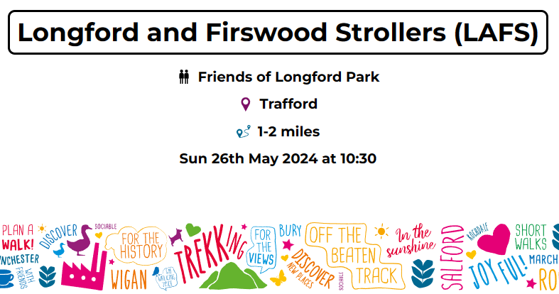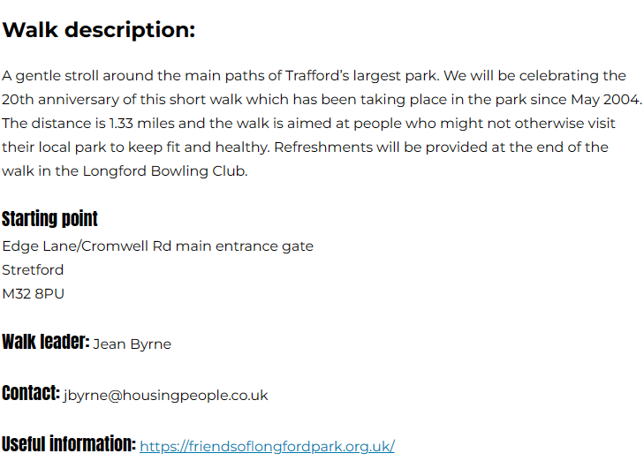

For a full list of the walks in Stretford and Old Trafford and all 358 walks throughout Greater Manchester follow this link to Festival Walks 2024 (gmwalking.co.uk).

