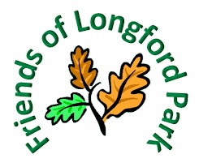
All Welcome

Equipment Provided

Join us for our Monthly
Litter Pick
Last Sunday of every month

9.30am - 11am
Meet next to the café
Next one
Sunday 26th November

Sunday

