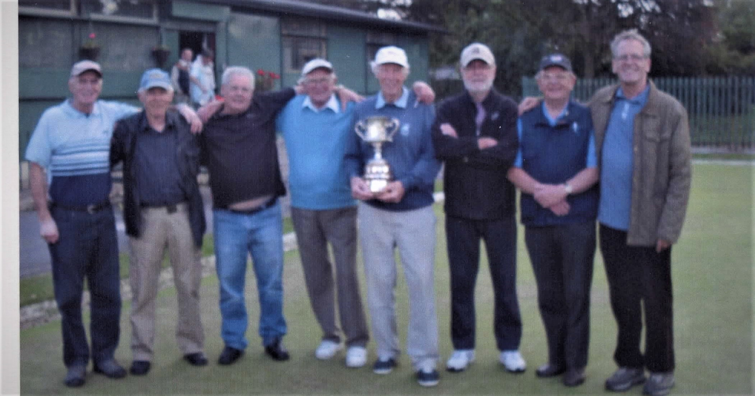

New Members Needed Season Starts Monday 23rd March 2020

Bowls is one of the few sports which allow you to keep on competing indefinitely. One of last year’s tournament winners in Trafford is 87 years old. Not many people can say they are a champion at that age. Bowling offers a way to keep active right through life.

Our sociable friendly club has been meeting in Longford Park Stretford since 1935. We are members of the Trafford Veteran’s League. League matches take place on Monday afternoons
Social bowling is from 1PM until 3.30PM Monday to Friday
Members may also use the greens at other times to practice as required.
During the season we have 8 in house competitions and an away day picnic event at Bacup in August
Bowls are available for new members to borrow to try what weight suits them
Indoor bowling is played in the winter months, "long mat” at Altrincham leisure centre or "short” mat at several venues in Trafford
Other social activities during the winter months include snooker, cards and dominoes

If you are interested in joining or would like to know more please contact Friends of Longford Park by email info@folp.org.uk or fill in a contact form on the web site friendsoflongfordpark.org.uk

Spectators are welcome to come in and watch a match. Please call in to the greens to have a look around whenever the gate is open

An initiative supported by Friends of Longford Park. Aiming to unlock the power of sport and physical activity to strengthen communities and networks

